
THE CHINESE UNIVERSITY

OF HONG KONG (SHENZHEN)

School of Science and Engineering

Tutorial - 7

Fundamental of Artificial Intelligence CSC3180

- Answer the following questions:

- What is “Pattern”? According to its definition in L8: P4-7, could you list some patterns in your daily life?
- “Pattern Recognition (PR)” is defined in L8: P8. Could you give some PR samples and tell which features you use?
- PR is an important component in both ML(Machine Learning) and AI. Please explain why? (L8: P9-10)
- In P11-13, a PR system is given. Please understand each function in the system.
- Understand the definitions related to PR: Classification, Recognition, Description, Pattern Class and Preprocessing (L8: P14-15). Why classification and recognition require the different classes, c and c+1, respectively.
- There are the main two parts, feature extraction/selection and classifier design, in a PR model. Please understand each basic contents.

- A 3-D example for pattern extraction is defined in L8: P16-18. There are four kinds of features are extracted. Please select these features according to some guidelines (L8: P27-28) to classify the given six objects, and then to represent selected features with two values by a true table (One selection: Edge + Symmetry + Axis)

- A minimum-error classifier based on || x - mk || is defined in L8: P41. How to get a linear discriminant function, g(x) = m' x - 0.5 || m ||${}^{2}$ in L8: P43? Which difference between the following two classifiers using the approaches mentioned above.
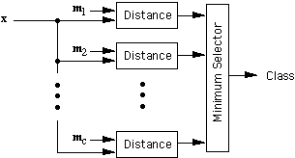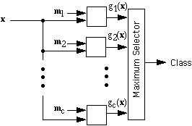

- In L8: P33 there are two templates (“D” and “O”) and ten input samples, each five. Please classify the third input example in the “D” row by using the maximum correlation approach and minimum error approach, respectively. (For Maximum Correlation Approach: “D”-Input: 82/90=91% and “O”-Input: 66/90=73%)

